Assignment-I

Python Programming (ITO- 804)



# Submitted By

**Name of Student: Arpit Khajuria Roll Number: 191203094 Branch: CSE**

# Semester:8th

**Submitted To Saurabh Sharma**

# Assistant Professor (CSE Department)

**Department of Computer Science and Engineering Model Institute of Engineering and Technology (Autonomous)**

**Jammu, India**

**Index**

|  |  |  |
| --- | --- | --- |
| **S.no** | **Question** | **Marks** |
| 1 | Write a Python program that takes a list of daily stock prices as input, and returns the best days to buy and sell stocks in order to maximize profit. The list contains the stock prices for each day, starting from the first day. For example, the list (100, 180, 260, 310, 40, 535, 695) represents the stock prices for 7 days, where the price on the first day is 100, the second day is 180, and so on. The program should find the best days to buy and sell stocks such that the profit obtained is maximum. For instance, in the given list of stock prices, the best days to buy and sell stocks would be: Buy stock on the 1st day (price=100) Sell stock on the 4th day (price=310) Buy stock on the 5th day (price=40) Sell stock on the 7th day (price=695) The program should  output these buy and sell days as a tuple or list of integers. | 2.5 |
| 2 | You are given a list of book titles and their corresponding publication years. Your task is to find the earliest year in which a trilogy of books was published. A trilogy is defined as a series of three books published in consecutive years. For example, consider the following list of book titles and publication years: titles = ['The Hunger Games', 'Catching Fire', 'Mockingjay', 'The Lord of the Rings', 'The Two Towers', 'The Return of the King', 'Divergent', 'Insurgent', 'Allegiant'] years = [2008, 2009, 2010, 1954, 1955, 1956, 2011, 2012, 2013] The  earliest year in which a trilogy was published is 1954.  Write a Python function earliest_trilogy_year(titles: List[str], years: List[int]) -> Optional[int] that takes two lists as input: titles containing the titles of the books, and years containing their corresponding publication years. The function should return the earliest year in which a trilogy of books was published, or None if no such trilogy exists. Examples: titles  = ['Book1', 'Book2', 'Book3', 'Book4', 'Book5', 'Book6'] years = [2019, 2021, 2012, 2013, 2016, 2017] print(earliest_trilogy_year(titles, years))  The earliest year in which a trilogy was published is : None A trilogy is defined as a series of three books published in consecutive years.  Note: • You can assume that the input lists are non-empty and contain  an equal number of elements. • If multiple trilogies exist with the same earliest year, return that year. | 2.5 |

|  |  |  |
| --- | --- | --- |
| 3 | Write a Python program that reads in a CSV file of stock prices (e.g. ticker symbol, date, price), and then uses dictionaries and lists to calculate the highest and lowest prices for each stock from following table. | 2.5 |
| 4 | A) Write a Python program to remove duplicates from a list of lists. Sample list: [[10, 20], [40], [30, 56, 25], [10, 20], [33], [40]] B) Write a Python program which takes a list and returns a list with the elements "shifted left by one position" so [1, 2, 3] yields [2, 3, 1]. Example: [1, 2, 3] → [2, 3, 1] [11, 12, 13] → [12, 13, 11] C) Iterate a given list and count the occurrence of each element and create a dictionary to show the count of each element. Original list [11, 45, 8, 11, 23, 45, 23, 45, 89, 11, 89] And expected output is: Printing count of each item {11: 3, 45: 3, 8:  1, 23: 2, 89: 2} | 2.5 |

Q1.

Write a Python program that takes a list of daily stock prices as input, and returns the best

days to buy and sell stocks in order to maximize profit.

The list contains the stock prices for each day, starting from the first day. For example, the list (100, 180, 260, 310, 40, 535, 695) represents the stock prices for 7 days, where the price on the first day is 100, the second day is 180, and so on. The program should find the best days to buy and sell stocks such that the profit obtained is maximum. For instance, in the given list of stock prices, the best days to buy and sell stocks would be: Buy stock on the 1st day (price=100) Sell stock on the 4th day (price=310) Buy stock on the 5th day (price=40) Sell stock on the 7th day (price=695) The program should output these buy and sell days as a tuple or list of integers.

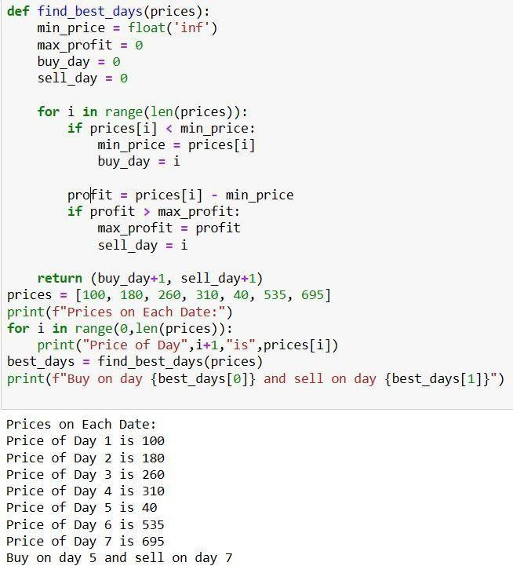Program:

def find_best_days(prices): min_price = float('inf') max_profit = 0 buy_day = 0 sell_day = 0

for i in range(len(prices)):

if prices[i] < min_price: min_price = prices[i] buy_day = i

profit = prices[i] - min_price if profit > max_profit: max_profit = profit sell_day = i

return (buy_day+1, sell_day+1) prices = [100, 180, 260, 310, 40, 535,

695] print(f"Prices on Each Date:")

for i in range(0,len(prices)): print("Price of Day",i+1,"is",prices[i])

best_days = find_best_days(prices) print(f"Buy on day {best_days[0]} and sell on day {best_days[1]}") You are given a

list of book titles and their corresponding publication years. Your task is to find the earliest year in which a trilogy of books was published. A trilogy is defined as a series of three books published in consecutive years. For example, consider the following list of book titles and publication years:

titles = ['The Hunger Games', 'Catching Fire', 'Mockingjay', 'The Lord of the Rings', 'The Two Towers', 'The Return of the King', 'Divergent', 'Insurgent', 'Allegiant'] years = [2008, 2009, 2010, 1954, 1955, 1956, 2011, 2012, 2013] The earliest year in which a trilogy was

published is 1954.

Write a Python function earliest_trilogy_year(titles: List[str], years: List[int]) -> Optional[int] that takes two lists as input: titles containing the titles of the books, and years containing their corresponding publication years. The function should return the earliest year in which a trilogy

Q2.

of books was published, or None if no such trilogy exists. Examples: titles = ['Book1', 'Book2', 'Book3', 'Book4', 'Book5', 'Book6'] years = [2019, 2021, 2012, 2013,

2016, 2017]

print(earliest_trilogy_year(titles, years))

The earliest year in which a trilogy was published is : None

A trilogy is defined as a series of three books published in consecutive years. Note: • You can assume that the input lists are non-empty and contain an equal number of elements. • If multiple trilogies exist with the same earliest year, return that year.

Program:

def find_trilogy_year(books): years = sorted(set(books.values()))

for i in range(len(years)-2): if (years[i+2] - years[i+1] == years[i+1] - years[i]) and \ any(years[i+1] == year for book, year in books.items() if years[i] <= year <= years[i+2]): return years[i] return None

books = {'The Hunger Games': 2008, 'Catching Fire': 2009, 'Mockingjay': 2010, 'The Lord of the Rings': 1954, \

'The Return of the King': 1956, 'Divergent': 2011, 'Insurgent':2012,'Allegiant':2013, 'The Two Towers':1955}

trilogy_year = find_trilogy_year(books)

print(f"The earliest year in which a trilogy was published is {trilogy_year}")

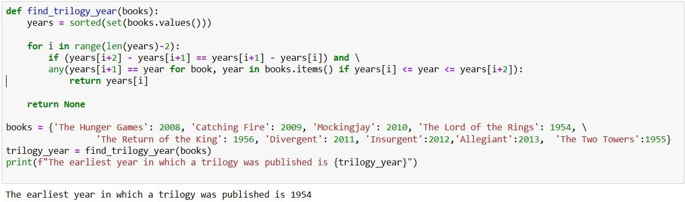

Write a Python program that reads in a CSV file of stock prices (e.g. ticker symbol, date, price), and then uses dictionaries and lists to calculate the highest and lowest prices for each stock from following table:

Q3.

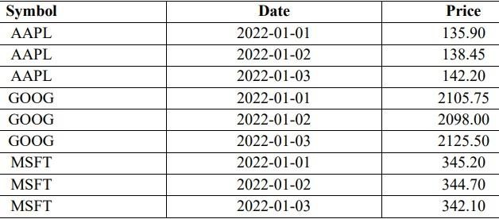

Program:

import csv with open('3_csv.csv') as file:

reader = csv.reader(file)

next(reader) # Skip the header row prices = {} # Create an empty dictionary to store the prices for each stock

for row in reader:

# Extract the symbol, date, and price from the row ticker, date, price = row

# Convert the price from a string to a float price = float(price)

# Check if the ticker symbol is already in the dictionary if ticker in prices:

prices[ticker].append(price)

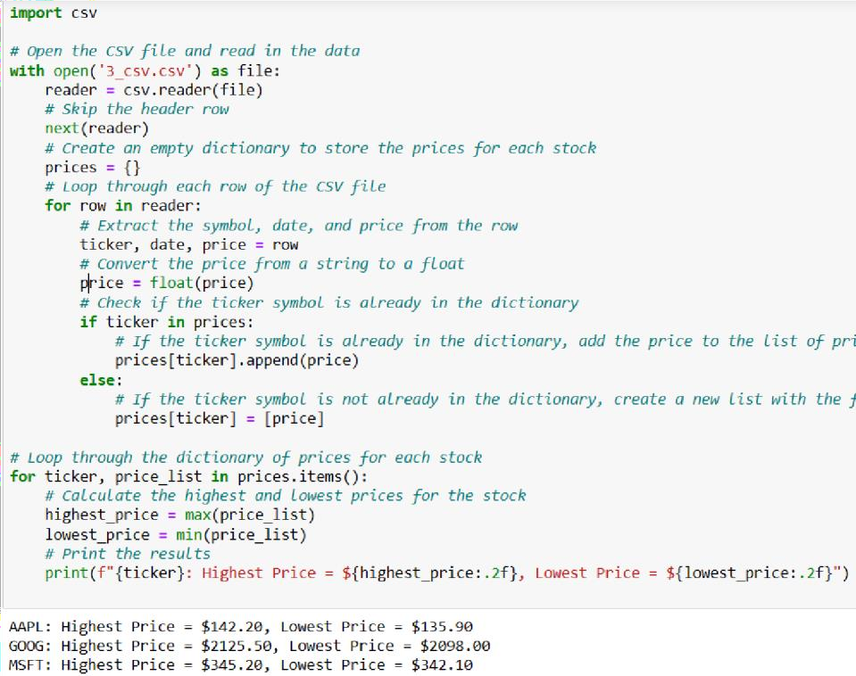else:

prices[ticker] = [price] for ticker, price_list in prices.items():

highest_price = max(price_list) lowest_price

=

min(price_list) print(f"{ticker}: Highest

Price = ${highest_price:.2f}, Lowest Price =

${lowest_price:.2f}")

Q4.

1. Write a Python program to remove duplicates from a list of lists. Sample list: [[10, 20], [40], [30, 56, 25], [10, 20], [33], [40]

Program:

# Define the list of lists with duplicates

list_of_lists = [[10, 20], [40], [30, 56, 25], [10, 20], [33], [40]]

# Create an empty set to store the unique lists unique_lists = set()

# Loop through each list in the original list of lists for lst in list_of_lists:

# Convert the list to a tuple (because lists are not hashable, but tuples are) lst_tuple = tuple(lst)

# Add the tuple to the set of unique tuples unique_lists.add(lst_tuple)

# Convert the set of unique tuples back to a list of lists unique_list_of_lists = [list(lst_tuple) for lst_tuple in unique_lists]

# Print the original list of lists and the unique list of lists print("Original List of Lists:")

print(list_of_lists) print("Unique List of Lists:") print(unique_list_of_lists)

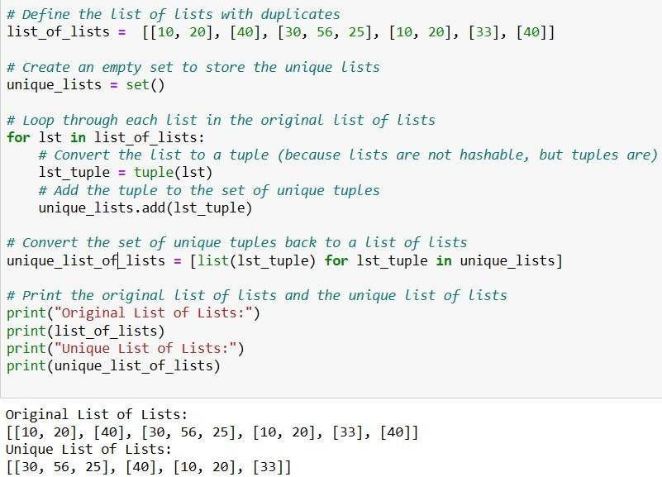

1. Write a Python program which takes a list and returns a list with the elements "shifted left by one position" so [1, 2, 3] yields [2, 3, 1]. Example: [1, 2, 3] → [2, 3, 1] [11, 12, 13] → [12, 13,

11]

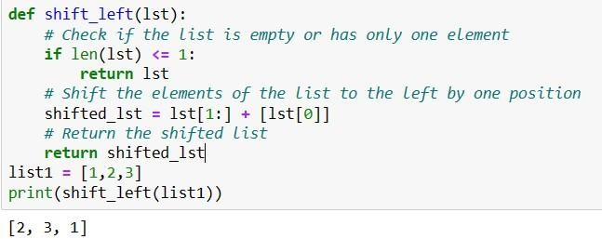Program: def shift_left(lst):

# Check if the list is empty or has only one element if len(lst) <= 1:

return lst

# Shift the elements of the list to the left by one position shifted_lst = lst[1:] + [lst[0]] # Return the shifted list return shifted_lst

list1 = [1,2,3] print(shift_left(list1))

1. Iterate a given list and count the occurrence of each element and create a dictionary to show the count of each element. Original list [11, 45, 8, 11, 23, 45, 23, 45, 89, 11, 89] And expected

output is: Printing count of each item {11: 3, 45: 3, 8: 1, 23: 2, 89: 2}

Program:

def count_occurrences(lst):

# Create an empty dictionary to store the count of each element count_dict = {}

# Loop through each element in the list for elem in lst:

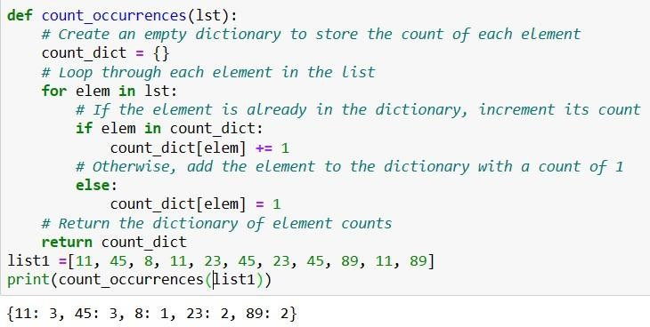# If the element is already in the dictionary, increment its count if elem in count_dict: count_dict[elem] += 1

# Otherwise, add the element to the dictionary with a count of 1 else:

count_dict[elem] = 1 # Return the dictionary of

element counts return count_dict

list1 =[11, 45, 8, 11, 23, 45, 23, 45,

89, 11, 89]

print(count_occurrences(list1))